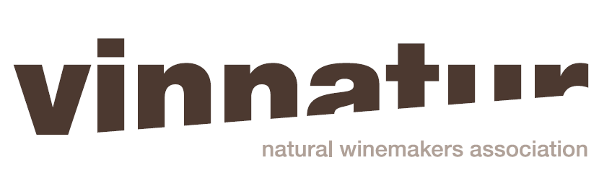

FOR IMMEDIATE RELEASE

Media Contact:
Irene Graziotto
Studio Cru International Press Officer
+39 335 7298712
press@studiocru.com

VINNATUR IS BACK AGAIN!
SOON ON SHOW AT VILLA FAVORITA (VICENZA- ITALY) ONE OF THE BIGGEST NATURAL WINE EVENTS

VinNatur keeps growing. The new Procedure Guideline, biodiversity conservation and continuous research are some of VinNatur proactive projects. The chance to take a closer look is Villa Favorita, from 14h to 16h April in Sarego (Vicenza) with 160 producers from 7 Countries

Natural wines are arguably one of the most interesting landscapes in present-day wine world. However, not all producers intend to go beyond this attractive but blurry label. On the contrary, VinNatur Association, which reunites 190 natural wine producers from nine different Countries in Europe, has made a point of honour that consumers understand what they are drinking, what “natural wine” expression guarantees when referring to VinNatur wines. This reason has led VinNatur to create the first Procedure Guideline (here) in the natural wine panorama, which has been approved in July 2016.

Angiolino Maule, President of VinNatur, explains: “We wanted to go beyond a simple self-certification. From this year, VinNatur wine consumers will drink wines which have been officially certified by external laboratories verifying that no pesticides, no herbicides, no chemical fertilizers have been used. Checks are done every year and are mandatory for each producer”. Many steps forwards have been made from 2006 when VinNatur was founded and continuous research plays a key-role. “We are already trying to get rid of copper and sulfur in the vineyards, using instead vegetable extracts that help the vine building up resistance” reveals Angiolino Maule. Along with this, VinNatur promotes biodiversity conservation, being it a very important ally for creating a balanced environment and producing wines expressing sense of place.

Nowadays VinNatur associates amount to 190 wineries – at the begigging there were only 65 estates – for a total of 1500 hectares and 6,5 million bottles of natural wine with 5 million produced in Italia.

Villa Favorita, one of the biggest natural wine fairs in the world, is the chance to take a closer look at VinNatur. It will host, from 14th to 18th April, from 10 a.m. to 6 p.m., 160 producers coming from seven different Countries: Italy, France, Spain, Portugal, Austria, Germany and Slovenia.

