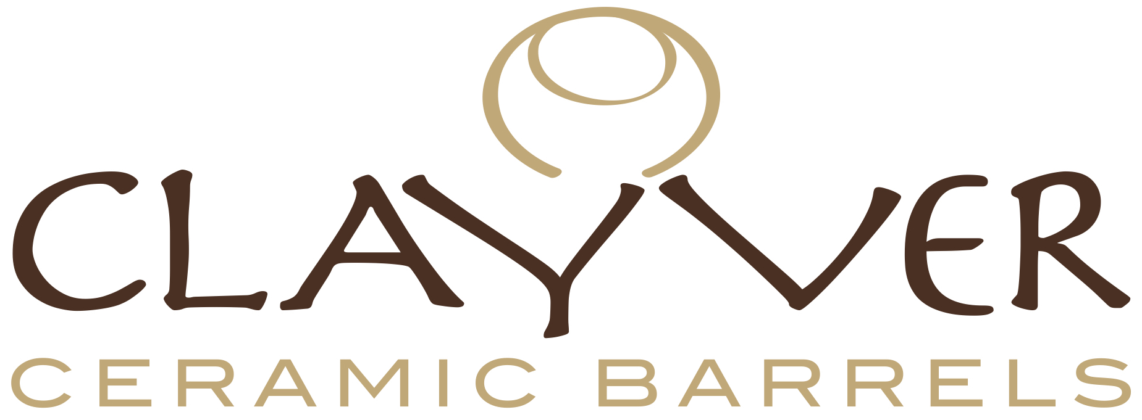

FOR IMMEDIATE RELEASE

Media Contact:
Studio Cru
Irene Graziotto
+39 339 7830186
press@studiocru.com

CLAYVER,
THE INTELLIGENT WINE POT

Suitable for both vinification and ageing, Clayver has surprised more than a few.
With a 2017 growth rate of +78%, the porcelain stoneware pot is conquering wine producers all over the world

July 5th, 2017 ‒ Created in 2014, Clayver has made a big hit in the market. After having conquered producers such as Tarlant with impressive results during comparative ageing trials, Clayver lands in US where it will be used for wine and even cosmetic products.

Clayver is an innovative stoneware round egg conceived for fermentation, vinification and wine ageing. Inspired by clay amphoras, Clayver inventors wanted to go beyond as far as mechanical resistance and impermeability. What makes a difference with traditional amphoras is shape and material.

Along with being aesthetically enjoyable, the round shape allows to keep the grape cap moist during fermentation, helping colour extraction. Convective movements contribute in reshuffling fine lees, thus improving wine structure and ageing potential. Wall thickness guarantees thermal inertia and a uniform, three-dimensional oxygen exchange concerning the smallest possible surface area. Stoneware is a resistant, isolating and easy to sterilize material, in addition to being safe when handling food – Clayver is certified for use in foodstuffs.
Guido Berlucchi, Livio Felluga, Le Macchiole are but a few names of producers who have been pleasantly surprised by results reached during comparative ageing trials and are now using Clayver.

Clayver has now 150 customers all over the world, with a +37% growth rate in the numbers of customers and a +78% in the amount of pieces ordered from 2016. It is now available in 2 different sizes: 250 and 400 litres.

If wine is Clayver intended use, it is not the only one. Cosmetics companies too have become interested in Clayver for the production of natural body and face lotions. Clayver in particular will be used for the maceration process being an inert material and therefore preventing any loss of matter from the container.

