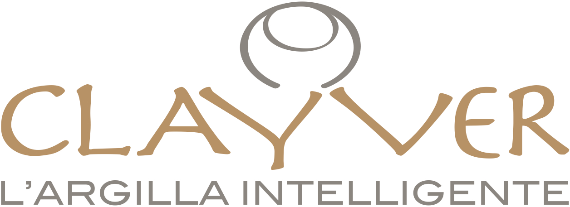

WHAT IS CLAYVER
Clayver is a pot specifically designed for vinification. It is used for both fermentation and ageing of wine.

WHY CLAYVER?
Clayver has been conceived by a group of professionals with an extensive experience in the clay and porcelain sector and the aim to respond to the call for high performing containers in the wine business. Clayver can be considered as an evolution of the traditional clay amphora as an alternative to barrique.

CLAYVER’S ADVENTAGES
As standard clay pots and small barrels, Clayver is used to preserve and age wine, allowing oxygen exchange, even if on a smaller scale and consequently for a longer ageing time. On the other side, Clayver is impermeable to liquids, therefore there is no product loss as it happens with wood and, especially, clay containers. As a consequence, Clayver does not need to be treated with wax, resin and enamel which are, on the contrary, frequently used for clay amphoras.
Clayver does not transfer any aromas to wine as does wood instead. A wine that has been aged in wood barrel tastes like wood, a wine that has been aged in Clayver, does not taste like Clayver.
Finally, Clayver lasts longer than a barrel and can be re-used for a limitless number of times.

MATERIALS
Clayver is made of a particular kind of homogenous and compact stoneware, for many aspects similar to natural granite. The research leading to patent Clayver has established a specific composition for the material, including a percentage of coarse material made of the same material cooked and ground, so to achieve a high level of resistance in the wine pot.
Differently from clay, Clayver has a very high level of mechanical resistance which makes it easier to move it around.
The microporous structure typical of clay allows oxygen exchange with the outside but only for a limited surface and on a long time span. Therefore, Clayver is suitable also for ageing wine in it even if for a long time.
Clayver is certified for use in foodstuffs.
Differently from what happens with coated concrete vats, cleaning Clayver is extremely easy. Water, steam, concentrated solutions of tartaric acid or citric acid are just some of the solutions.

SHAPE
Clayver is ideally a sphere with a short neck in the upper part where is located the closure. Along with its aesthetic value, the round shape has many advantages: it keeps the grape cap moist during fermentation and vinification, helping colour extraction. Convective movements developing during fermentation are not hindered but contribute on the contrary in keeping the mass homogenous and reshuffling fine lees, thus improving wine structure and ageing potential.
Wall thickness guarantees thermal inertia and a uniform, three-dimensional oxygen exchange concerning the smallest possible surface area.
Clayver’s top is perfectly flat so it grants a perfect closure even with a simple rectified glass tap. The Tap can be personalized, silk-screened and treated to protect against UV.

CAPACITY
Clayver is available in 2 different sizes: 250 and 400 litres.

